Chapter 15 (15.1 – 15.6)

- System at equilibrium: two opposing processes take place at equal rates; affects vapour pressure of a liquid, solubility of a solute, distribution coefficient represent physical equilibrium; decomposition of PCl₅ represents chemical equilibrium
- One consequence of the equilibrium condition is that the amounts of the reactants and products remain constant with time
- Reacting species are never completely consumed
- Where equilibrium systems are sufficiently close to idea in their behaviour, equilibrium concentrations are acceptable approximations to true activities
- When we reverse an equation we invert the value of K
- When we multiply the coefficients in a balanced equation by a common factor we raise the equilibrium constant to the corresponding power
- When we divide the coefficients in a balanced equation by a common factor we the corresponding root of the equilibrium constant
- When individual equations are combined (added) their equilibrium constants are multiplied to obtain the equilibrium constant for the overall reaction
- 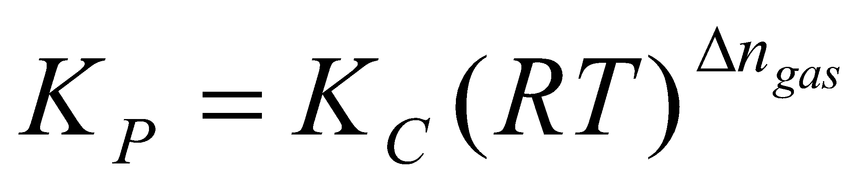
- Homogeneous Reactions: occur within a single phase (i.e. gas-phase reactions, aq reactions)
- Heterogeneous Reactions: reactions involving one or more condensed phases
- Equilibrium constant expressions do not contain concentration terms for solid or liquid phases of a single component – recall that the activities of pure liquids and solids are set equal to 1
- Value of the equilibrium constant relates to thermodynamic stability
- Very small numerical value of K signifies that the forward reaction does not occur to any significant extent
- A reaction is most likely to reach a state of equilibrium in which significant quantities of both reactants and products are present if the numerical value of K is neither very large nor very small, from 10⁻¹⁰ to 10¹⁰
- Reaction Quotient, Q: a ratio of activities having the same form as the equilibrium constant expression, if K=Q, the reaction is at equilibrium
  - If Q < K, a net change occurs form left to right (forward reaction)
  - If Q > K, a net change occurs from right to left (reverse reaction)
- Le Chatelier’s Principle: when an equilibrium system is subjected to a change in temperature, pressure, or concentration of a reacting species, the system responds by attaining a new equilibrium that partially offsets the impacts of the change
  - Changing the amounts of reacting species
  - Changing the pressure or volume: add or remove a gaseous reactant or product, add an inert gas to the constant-volume reaction mixture (increases total pressure, but partial pressures are all unchanged) → no effect on equilibrium condition if there are equal numbers of moles on both sides; change the pressure by changing the volume
    - When the volume of an equilibrium mixture of gases is reduced, a net change occurs in the direction that produces fewer moles of gas. When the volume is increases, a net change occurs in the direction that produces more moles of gas
  - Temperature: raising the temperature of an equilibrium mixture shifts the equilibrium condition in the direction of the endothermic reaction. Lowering the temperature causes a shift in the direction of the exothermic reaction
  - Catalyst: speeds up forward and reverse reactions, equilibrium is achiever faster, but amounts are unchanged (doesn’t change numerical value of constant)
    - A catalyst changes the mechanism of a reaction to one with a lower activation energy; a catalyst has no effect on the condition of equilibrium in a reversible reaction
  - Stretching of rubber is exothermic; shrinking of rubber is endothermic
- Homogeneous: single physical phase
- Heterogeneous: several physical phases
- Dynamic equilibrium occurs when the rate of the forward reaction is equal to the rate of the reverse reaction
- Synthesis of Ammonia: N_{2 (g)} + 3H_{2 (g)} ↔ NH_{3 (g)} 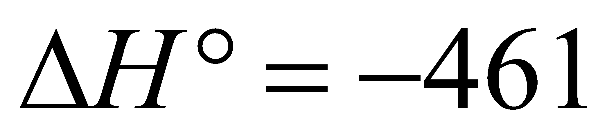 kJ/mol
  - Industrial Haber-Bosch Process
  - Requires high pressure (250 atm), moderate temperature (400 degrees) Fe catalyst
    - Catalyst increases kinetics of N₂ gas dissociation; increases speed of reaction
    - High pressure favours forward reaction and formation of ammonia
    - Too high of a temperature doesn’t favour formation of NH₃, however, if its too low, the reaction will not proceed
  - N₂ has triple bond; very strong bond, dissociation is very hard, requires lots of energy (large activation energy barrier)
  - N_{2 (g)} → N₂⁺ (adsorbed) → 2N (adsorbed)
    - N₂ is unreactive, N₂ is activated molecule with weaker bond
  - Ammonia is important→ for fertilizer → grow crops → food
- The chemical equation for a reversible reaction serves both to establish the form of the equilibrium constant expression and to provide the conversion factors (Stoichiometry factors) to relate the equilibrium quantity of one species to equilibrium quantities of the others

Chapter 16
- Arrhenius Theory: a neutralization reaction involves the combination of hydrogen ions and hydroxide ions to form water
- Bronsted-Lowry Theory: an acid is a proton donor; a base is a proton acceptor
  - Conjugate Pair: an acid and base that are related to each other, differ through one proton
- Base Ionization Constant: water acts as an acid in the reaction, but is ignored (activity of one) in equilibrium expression, leaving only the base as reactant
- Acid Ionization Constant: water acts as a base in the reaction, but is ignore (activity of one), leaving only the acid as the reaction
- Hydronium Ion: simple H⁺ ion is tiny, very concentrated charge, high positive charge density, ataches to a lone pair of electrons in an O atom in H₂O, the resulting hydronium ion forms hydrogen bonds with several water molecules
- Features of Acid-Base Reactions:
  - Any species that is an acid according to the Arrhenius theory is also an acid according to the Bronsted-Lowry theory; the same is true of bases
  - Certain species produce OH⁻ even though they do not contain the OH group (they are Bronsted-Lowry bases)
  - Bronsted Lowry accounts for substances that are amphiprotic (the Arrhenius does not)
- In an acid-base reaction, the favored direction of the reaction is from the stronger to the weaker member of a conjugate acid-base pair; therefore: the stronger an acid, the weaker its conjugate base
  - Conjugate bases of strong acids have essentially no basic properties
  - Conjugate acids of strong bases have essentially no acidic properties
- Ionic Product of Water: equilibrium condition for the self-ionization of water
K_{w} = [H₃O⁺][OH⁻]=1.0 x 10⁻¹⁴ [H₃O⁺]=[OH⁻]=1.0 x 10⁻⁷ M
  - Applies to all aqueous solutions
- pH: potential of hydrogen ion
pH= - log[H₃O⁺] pOH = -log[OH⁻]
  - pK_{w}=pH+pOH = 14.00
  - if the pH is less than 7.00, the solution is acidic, if the pH is greater than 7.00, the solution is basic, if the pH is 7.00, it is neutral
  - Range of pH scale extends beyond 0 and 14
  - pH indicators: phenolphthalein; acid form absorbs in UV colourless; base form absorbs in visible Red
  - pH indicator equilibrium: as pH varies, the raio of the two forms (acid form and base form) also varies)
    - Acid Form: [In⁻]/[InH] < or = 10⁻¹, pH < or + pK_{a} – 1
    - Base Form: [In⁻]/[InH] > or = 10⁻¹, pH > or + pK_{a} + 1
- Strong Acids and Strong Bases: reactions essentially go to completion; self-ionization of water can be ignored (unless the solution is extremely dilute)
  - Strong Acids: HCl, HBr, HI, HClO₄, HNO₃, H₂SO₄ª
  - Strong Bases: LiOH, NaOH, KOH, RbOH, CsOH, Mg(OH)₂, Ca(OH)₂…
- Weak Acids and Weak Bases
  - pK is related to an equilibrium constant: pK = -log K
  - You may use simplifying assumption method, for weak acids and bases, but you must check the assumption (should be valid to less than 5%)
- Weak Acid – partially ionized: AH + H₂O ↔ A⁻ + H₃O⁺
  - Acid Ionization Constant: K_{a} = [A⁻][H₃O⁺] / [AH]
  - K_{a} measures acid strength; as it increases, hydronium concentration increases, acidity increases
    - AH and A⁻ are a conjugate acid-base pair; A⁻ is conjugate base of AH acid (differ by a proton)
- Weak Base – partially ionized: B + H₂O ↔ BH⁺ +OH⁻
  - Base Ionization Constant: K_{b} = [BH⁺][OH⁻]/[B]
  - K_{B} measures base strength, as it increases, hydroxide concentration increases, basicity increase
    - BH⁺, B = conjugate acid-base pair; B is conjugate base of a BH⁺ acid
- Recall: pk = -logk
- Strength of Oxoacids: acidic hydrogen are bonded to oxygen; the one which is ionized
  - Hypochlorous Acid → HOCl: Polar O-H bond gives rise to acidity
  - Chlorous Acid → HClO₂: stronger polarization, stronger acidity due to the OH bond, because of another highly EN atom (O) double bonded and pulling on it
  - Perchloric Acid → HClO₄: even more polarization of OH bond due to another O
  - Acetic Acid and Chloracetic Acid: weak effect of polarization
  - Based on attraction of electrons from O-H bond toward central atom; O-H bonds must be weakened; which is affected by: a high Electronegativity of central atom, a large number of terminal O atoms in the acid molecule
- Why isn’t NaOH acidic? OH is a covalent bond but Na-O-H is ionic, Electronegativity difference is too big
- Polyprotic Acids: acids with more than one ionisable H atom per molecule
  - Phosphoric Acid: triprotic, three ionisable H atoms. (First K_{a} is the largest because as the proton moves away from the ion the separation becomes more and more difficult); essentially all the hydronium is produced in the first step, assume that [H₂PO₄⁻ ] = [H₃O⁺]
  - Sulfuric Acid: strong acid in first ionization, weak acid in second, H₂SO₄ is completely ionized after first step, therefore, at equilibrium, [H₂SO₄] = 0 M
- Ions as Acids and Bases
  - Ions can act as acids or bases (proton donor or acceptor)
  - The product of the ionization constants of an acid and its conjugate base equals the ion product of water:
K_{a} (acid) x K_{b} (its conjugate base) = K_{w}
K_{b} (base) x K_{a} (its conjugate acid) = K_{w}
  - Hydrolysis Reaction: a reaction between an ion and water; ammonium ion hydrolyzes; but some don’t hydrolyze (Cl- or Na+)
    - Salts of strong bases and strong acids (NaCl) do not hydrolyze
    - Salts of strong bases and weak acids (NaC₂H₃O₂) hydrolyze: pH > 7 (anion acts as a base)
    - Salts of weak bases and strong acids (NH₄Cl) hydrolyze: pH < 7 (cation acts as an acid)
    - Salts of weak bases and weak acids (NH₄C₂H₃O₂) hydrolyze. (The cations are acids, and the anions are bases. The values of Ka and Kb determine whether the solution is acidic or basic
    - If no hydrolysis, salt solution is neutral (i.e. NaCl reaction)
- Molecular Structure and Acid-Base Behaviour:
  - In general, the stronger the H-x bond, the weaker the acid is
  - Strong bonds are characterized by short bond lengths and high bond-dissociation energies therefore, the shorter the bond length and the higher the dissociation energy, the weaker the acid strength
  - Oxoacids: see above
  - Organic Acids: similar to oxoacids; presence of lone O, presence of external group (Cl); O-H bonds must be weakened
  - Amines as Bases: ability of the lone pair of electrons on the N atom to bind a proton taken from an acid; electronegative external groups added to N decrease the ability of N to bind a proton, thus weakening the base.
- 